Student ID: | CTI20221062
Student Name: | Leonardo Matias Ciarcia

Date/Time: | Monday, 17 November 2025, Time: 11AM
Location: | Room 4 , Level 8, 333 Adelaide Street, Brisbane. QLD 4000
Chairperson: | Leonardo Matias Ciarcia
Meeting Attendees:  Full names and roles | 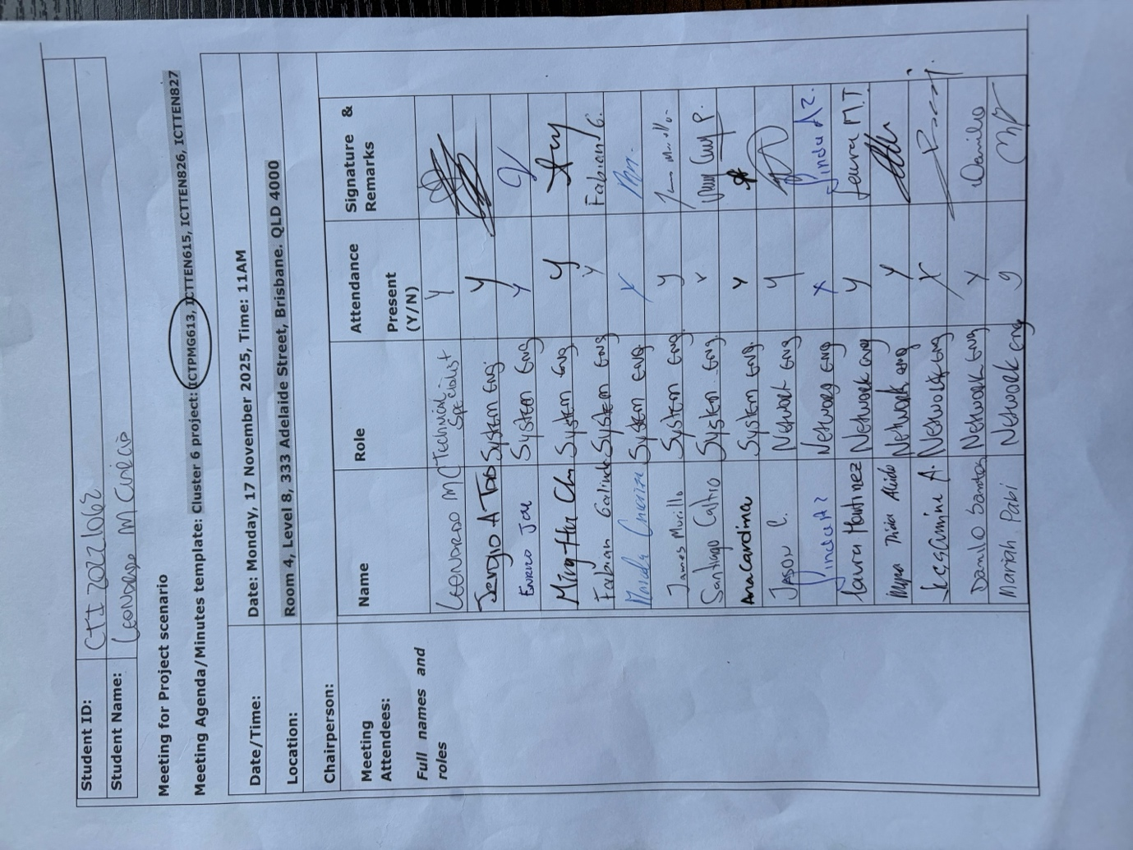  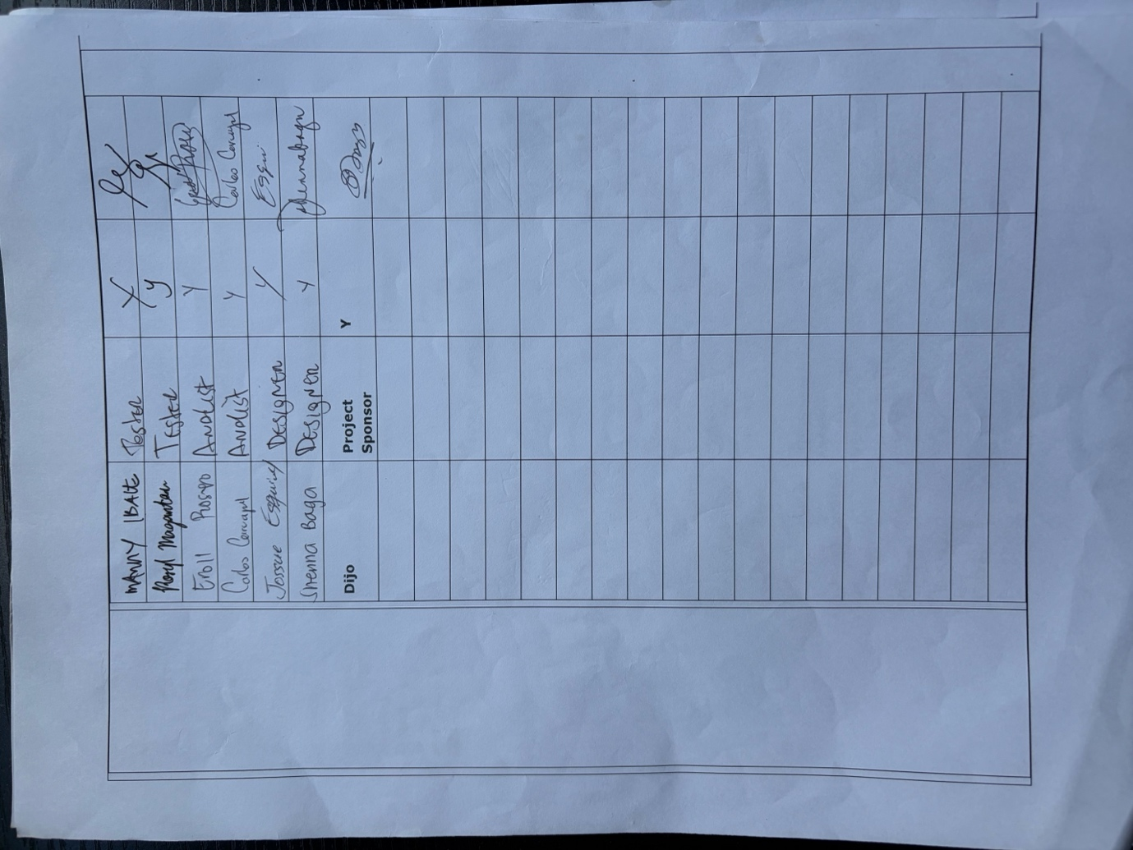  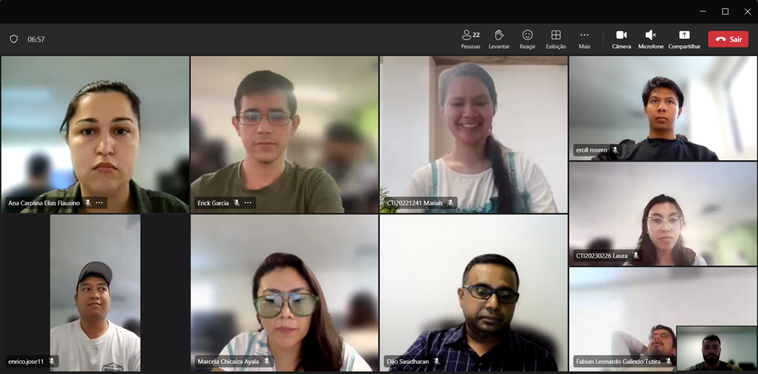  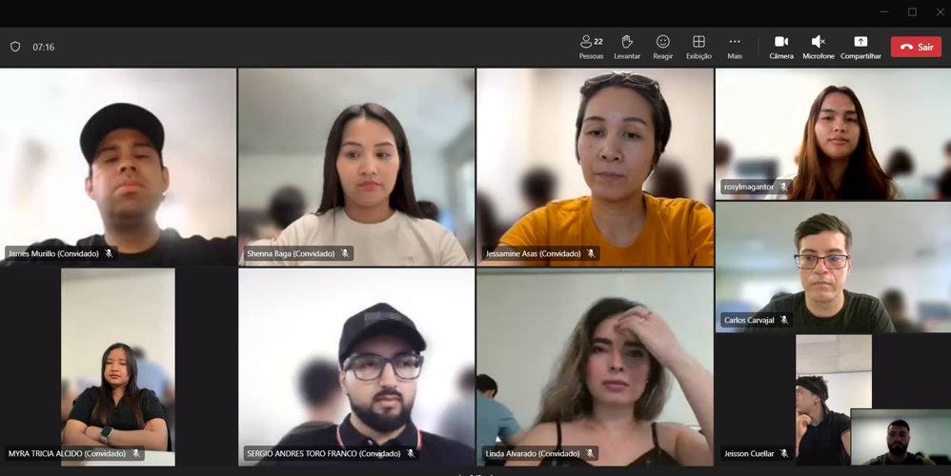  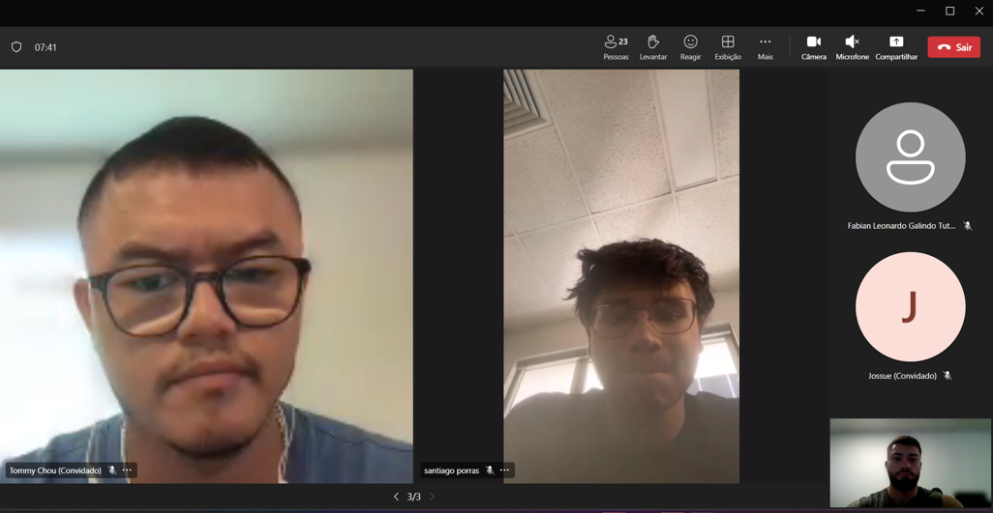
Agenda Item/Topic | Discussion/Activities/Outcomes |  | Action Officer | Target/  Due Date
Welcome | • welcomed the attendees and explained that the meeting would review the project methodology, control plans, schedule and budget for the Darvycom network upgrade.  • The meeting objectives and three agenda items were introduced. |  | Project Manager | 17/11/2025
(Agenda item 1)  Project Methodology and Control Plans  Topic?  - Establish how the project will be managed, monitored and controlled. | Motion moved by: Project Manager  Voting and Resolution:  • Voting: All attendees supported the proposed methodology and control arrangements.  • Resolution: The hybrid project methodology and project control plans were approved. |  | Project Manager | End of Project Week 2
  Details of discussion/activities (Points Discussed/ Activities completed) | Actions Suggested
  • Review the project scope, deliverables, exclusions and acceptance requirements.  • Confirm the hybrid project methodology, combining structured Waterfall planning with progressive testing and review.  • Review controls for scope, schedule, cost, quality, risk, communication, procurement and change requests.  • Confirm that project changes must be documented, assessed and approved before implementation. | • The hybrid methodology and project control plans were accepted.  • Regular status meetings and progress reports will be used to monitor performance.  • Significant changes or variances will be escalated to the Project Sponsor.
(Agenda item 2)  Project Schedule Development  Topic?  - Establish a realistic schedule for completing the Darvycom project. | Motion moved by: Project Manager  Voting and Resolution:  • Voting: All attendees supported the proposed schedule.  • Resolution: The 24-week Gantt chart and task list were approved as the project schedule baseline. |  | Project Manager and Technical Team Leaders | End of Project Week 4
  Details of discussion/activities (Points Discussed/ Activities completed) | Actions Suggested
  • Review the 24-week project schedule.  • Confirm the stages of initiation, planning, requirements analysis, design, procurement, implementation, integration, testing, training, handover and closure.  • Identify task dependencies, milestones, responsible resources and critical activities.  • Discuss how delays and schedule changes will be recorded and managed. | • The Gantt chart and Project Schedule Task List were accepted as the schedule baseline.  • Progress will be reviewed against planned milestones.  • Delayed critical tasks will require corrective action and schedule review.
(Agenda item 3)  Project Budget Finalisation  Topic?  - Approve the project budget and establish financial controls. | Motion moved by:  Finance/Procurement Officer  Voting and Resolution:  • Voting: All attendees supported the proposed budget arrangements.  • Resolution: The AUD 184,800 working budget baseline was approved within the AUD 200,000 funding ceiling. |  | Project Manager and Finace | End of Project Week 5, before procurement begins
  Details of discussion/activities (Points Discussed/ Activities completed) | Actions Suggested
  • Review labour rates, network equipment, software, installation, testing, training and cost-of-quality expenses.  • Review anticipated expenditure and the timing of project cash flows.  • Confirm the AUD 184,800 working cost baseline within the AUD 200,000 funding ceiling.  • Review the remaining AUD 15,200 reserve and the approval process for using contingency funds. | • The working budget baseline was approved.  • Purchases must follow procurement and approval procedures.  • Actual spending will be compared with the budget, and cost variances will be reported.  • Contingency funds cannot be used without authorisation.
Summary | Overall Summary:  The project team reviewed the management methodology, project controls, 24-week schedule and financial arrangements for the Darvycom network upgrade.  Decision/s:  • The hybrid project methodology was approved.  • The project control plans were accepted.  • The 24-week schedule was approved as the schedule baseline.  • The AUD 184,800 working budget was approved within the AUD 200,000 ceiling.  Action/s if any:  • The Project Manager will distribute the approved plans.  • Technical Team Leaders will monitor assigned activities.  • The Finance/Procurement Officer will monitor expenditure and procurement.  • Project progress, costs, risks and changes will be reviewed regularly.
Next Meeting time/date | 19/01/2026 |  | Leonardo | 17/11/2025
Meeting closed at: | 12PM |  | Leonardo | 17/11/2025
Minutes are a true and accurate record of the meeting | Approved/confirmed by: (who?)  Dijo Sasidharan |  | Dijo Sasidharan | 17/11/2025
Signature of attendee 1: Leonardo   |  | Signature of attendee 3: Dijo  

